Dear Wyndcroft Player Families,
We are very pleased to announce the musical for the 2019-2020 school year: High School Musical Jr.
Last year's production of Lion King was a huge success; that was thanks to the cast, crew, and the parents who worked tirelessly to bring everything together. This year, we are excited to bring another excellent production to Wyndcroft. With that in mind, we would like to remind returning Wyndcroft Player families and explain to new families the attendance policy for the musical.
We believe that, whether a chorus member or a leading role, each cast member is essential to the overall quality of the show. Anytime someone is missing, it means that the next rehearsal, we have to go back and teach them the choreography, music, and/or blocking that they may have missed. This time could instead be used to improve the quality of the show.
We realize that your child has several extracurricular activities that they are involved in and sometimes there are scheduling conflicts. Just like a sport, where it would be impossible for your child to miss all of their practices, skip the regular season, then head straight to the championship game, it is just as impossible for your child to miss their rehearsals and still expect a great show.
So, with a great show in mind, we will abide by the following attendance policy:
-Three total afterschool absences- your child is allowed THREE ABSENCES. We ask that, if at all possible, you let us know in writing if your child is going to be absent. In the event of an illness or an unexpected absence, please email Phillip Ballantine (pballantine@wyndcroft.org) as soon as possible.
-There are no absences permitted on Feb 29th and from March 16th until the performance.
-Lateness- arriving later than 30 minutes after the posted start time of each rehearsal or leaving more than 30 minutes before the posted end time of each rehearsal will count as an absence.
We realize this is a large commitment for both you and your child. It is our goal to help create a show that our students, parents, and community are proud of. The commitment of you and your child will help us achieve that goal. We’ve attached a tentative rehearsal schedule so that you and your child can decide if this is a commitment that will work for you. We thank you in advance for your understanding and support. Please feel free to contact Phillip Ballantine (pballantine@wyndcroft.org) with any questions or concerns you may have.
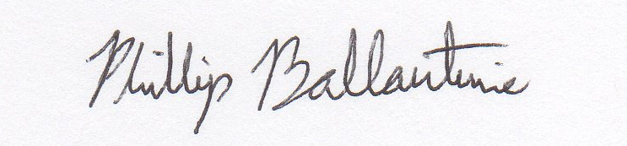
Sincerely,

Phillip Ballantine
and the Production Staff

